Before you begin
Please use the same account for all registrations. This will ensure proper assessment tracking for your skater and avoid any membership fee duplication.
Click the Login button on the right-hand side of the screen


Click on the First Time Registering tab, then fill out all information required, and then click Create Account
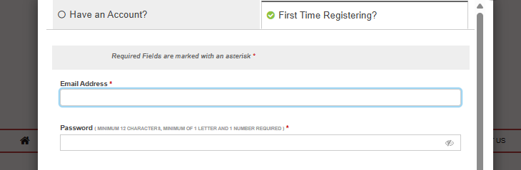
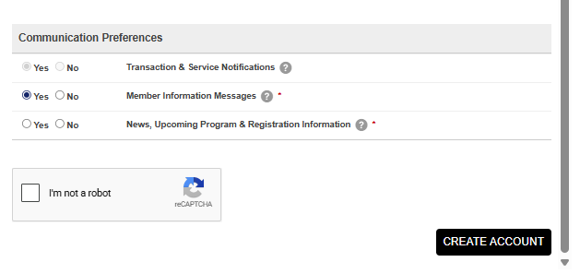
Add billing address and save
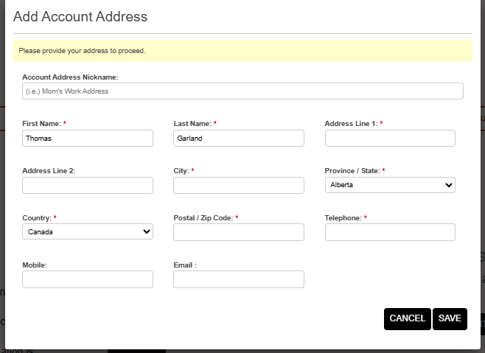
Once back to main page, click your Name and then My Account. You will then be asked to verify your account via email.
